

**Auto Car movement by hand gestures**

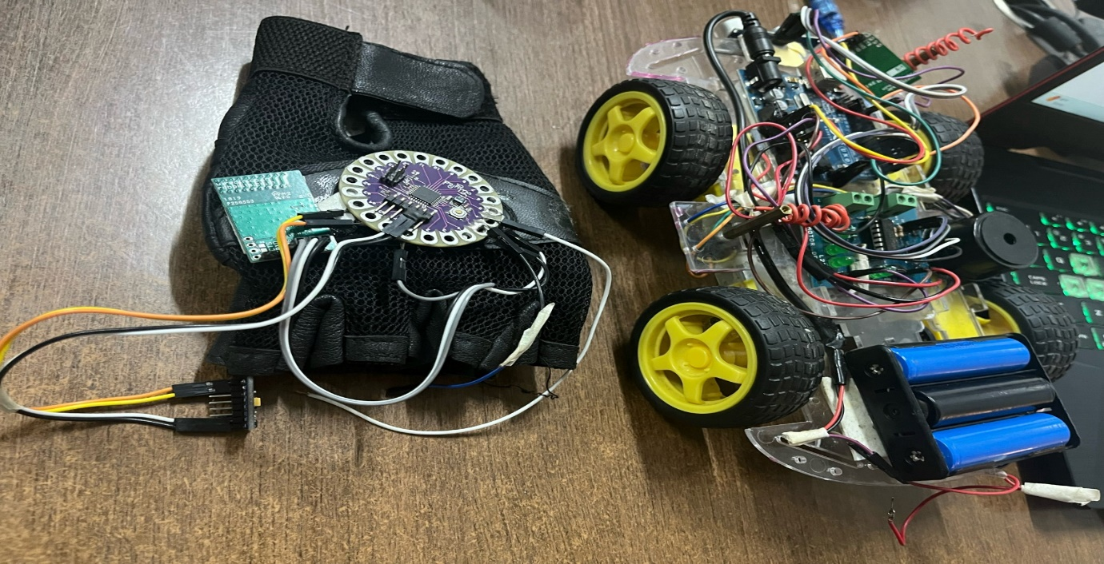

**Mentor: Team Members**

Ashish Sharma T.Somasree

Abhishek Kumar

Aayush Kharkia

Suraj Kumar

**Introduction**

Think about driving your car without touching a single button – just moving your hands to control it. That's the idea behind the Gesture-Controlled Auto Car project. It's all about making driving easier and safer by using hand gestures to do things like adjusting the radio or opening windows. This project is using the latest technology to make cars more user-friendly and accessible for everyone.

**What It's All About**

The Gesture-Controlled Auto Car project is like something out of a sci-fi movie, but it's becoming real. It's all about letting you control your car with simple hand movements. Instead of reaching for buttons or knobs, you can just wave your hand to make things happen. Imagine turning up the volume on your music by just flicking your wrist, or rolling down the window with a swipe of your hand. It's like magic, but it's all thanks to some really smart technology.

**How It Works**

This project is packed with fancy sensors and cameras that watch your hands and figure out what you want to do. It's kind of like having a super-smart robot assistant in your car. These sensors can understand a bunch of different hand gestures, so you can communicate with your car without even saying a word. And the best part? It's always learning, getting better at understanding you the more you use it.

**Making Driving Better**

Using hand gestures to control your car isn't just cool – it's also safer. You can keep your eyes on the road and your hands on the wheel while still doing stuff in your car. No more fumbling around with buttons or getting distracted by screens. Plus, it's not just for people who can move easily. This project is all about making driving easier for everyone, including people with disabilities. It's like giving everyone their own personal driving assistant.

**What's Next?**

The Gesture-Controlled Auto Car project is just getting started. As technology gets even smarter, the possibilities are endless. Who knows? Maybe one day, driving with your hands might feel as old-fashioned as using a flip phone. The future of driving is looking pretty exciting, and it's all thanks to projects like this one. So, get ready to wave goodbye to the old way of driving and say hello to the future.

**OBJECTIVE**

1. Make Driving Easier and Safer: Help drivers control their cars more effortlessly by using hand gestures instead of reaching for buttons or screens. This makes driving safer because it keeps their hands on the wheel and eyes on the road.

2. Include Everyone: Ensure that everyone, including people with disabilities, can easily use this technology. By making the interface intuitive and accessible, everyone can enjoy the benefits of gesture-controlled driving.

3. Keep Focus on the Road: Reduce distractions for drivers by allowing them to perform tasks without taking their attention away from driving. This helps prevent accidents and makes the roads safer for everyone.

4. Stay Ahead with Innovation: Continuously improve the technology to make it even better and explore new ways to use gesture control in cars. This keeps driving exciting and opens up possibilities for future innovations in vehicle technology.

**Literature review**

Gesture-controlled technology in cars is like something out of a sci-fi movie, but it's becoming real. This review dives into what researchers have discovered about using hand gestures to control cars. We'll explore how it could make driving safer, more convenient, and accessible for everyone.

Understanding Gesture-Controlled Car Tech

Gesture-controlled car tech lets drivers do things like change the radio station or adjust the air conditioning, all with hand movements instead of touching buttons or screens. It's made possible by fancy sensors and cameras that watch your hands and figure out what you want to do.

The Good Side: Benefits of Gesture-Controlled Cars

Research suggests there are some big perks to using gesture controls in cars. First off, it could make driving safer by letting drivers keep their hands on the wheel and their eyes on the road. Plus, it's easier and more fun – who wouldn't want to control their car with a flick of the wrist?

Another cool thing is that it could help people with disabilities drive more easily. By making the controls simple and intuitive, gesture tech opens up driving to more people.

The Challenges: What Needs Figuring Out

But it's not all smooth sailing. Sometimes the tech might get confused or not work as well in different lighting or driving conditions. And there's a learning curve – it might take some practice to get the hang of using hand gestures to control your car.

There's also the risk of accidentally triggering commands with unintended gestures, which could be annoying or even dangerous. Designers need to make sure the system is easy to use and doesn't cause any headaches.

Looking Ahead: What's Next for Gesture-Controlled Cars

Despite the challenges, researchers are excited about the possibilities. They're working on making the tech even better and exploring new ways to use gesture controls in cars. Imagine waving goodbye to old-fashioned buttons and screens and saying hello to a whole new way of driving.

**Workflow Diagram with explanation**

1. Input Stage

At the beginning of the process, the system receives input from the user's hand gestures. This input stage involves two main steps:

1.1 Camera and Sensor Configuration

In this step, cameras and sensors placed strategically within the car environment capture the hand gestures made by the driver or passengers. These cameras and sensors are positioned in such a way to cover various areas where gestures might occur, like near the dashboard or steering wheel.

1.2 Data Acquisition

Once the cameras and sensors capture the gestures, the system collects and gathers the data. This data includes information about the position, movement, and shape of the hands as they perform different gestures.

2. Processing Stage

After acquiring the gesture data, the system processes it to recognize and interpret the gestures accurately. This stage involves:

2.1 Computer Vision Algorithms

Sophisticated computer vision algorithms analyze the captured data to understand the gestures. These algorithms are like smart programs that can identify patterns and shapes in the hand movements, allowing the system to recognize specific gestures.

2.2 Machine Learning Integration

Machine learning algorithms are then employed to further refine the gesture recognition process. These algorithms learn from the data collected over time, improving their ability to interpret gestures accurately. Essentially, the system gets better at recognizing gestures the more it's used.

3. Execution Stage

Once the gestures are recognized and interpreted, the system executes the corresponding commands within the vehicle's control system. This stage involves:

3.1 Command Transmission

The system sends the interpreted gestures as commands to the vehicle's control unit. This unit is like the brain of the car, responsible for controlling various functions such as adjusting the volume, changing the radio station, or activating safety features.

3.2 Real-time Response

Finally, the vehicle's control unit responds to the commands received from the gesture recognition system in real-time. This means that actions like adjusting the volume or opening the windows happen immediately after the corresponding gesture is recognized, providing the driver with a seamless and instantaneous driving experience.

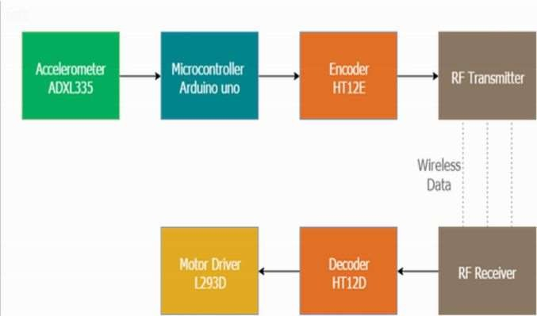

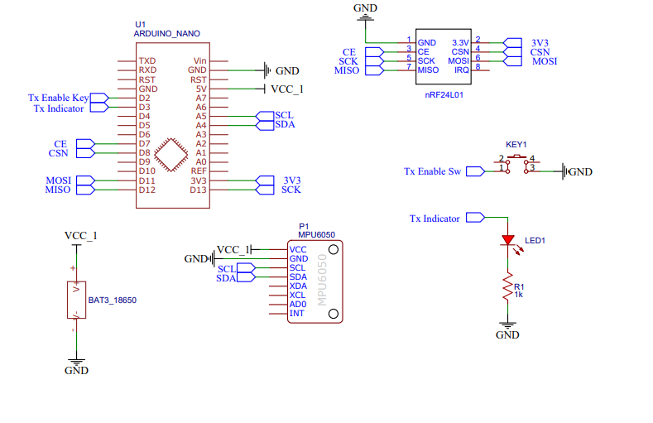

**Coding**

The 4WD Car Kit is like a DIY dream for remote-controlled car fans. It's designed to let you create your own four-wheel-drive car, giving you the freedom to customize it just the way you want. Whether you're a newbie or a seasoned builder, this kit makes it easy to put together with its modular design and simple-to-use parts.

Once assembled, this car is all about power and versatility. Thanks to its four-wheel drive, it can tackle all sorts of terrain with ease, offering superb traction and maneuverability. And the fun doesn't stop there—you can jazz up your ride with extra accessories and upgrades to really make it your own.

Whether you're into hobbies, educational projects, or even robotics competitions, the 4WD Car Kit has something for everyone. It's a fantastic way to dive into the exciting worlds of robotics and automotive engineering while having a blast along the way. Components

4wd Car kit : <https://amzn.to/2R5F7rP>

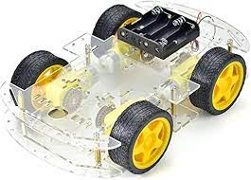

Arduino UNO : <https://amzn.to/3o3lP2h>

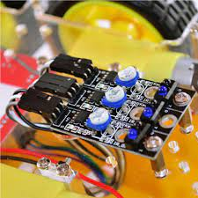

Arduino Nano : <https://amzn.to/3hjb4Yj>

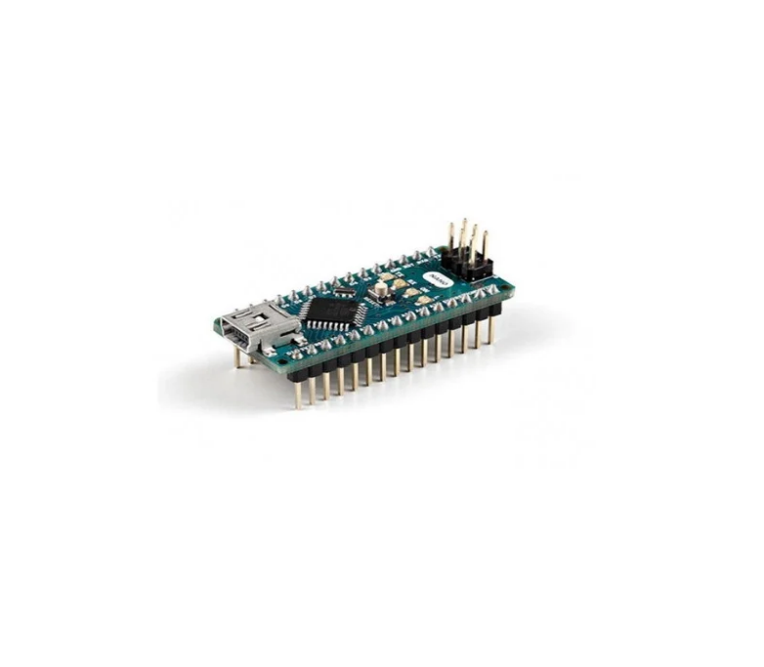

L298 Motor Driver : <https://amzn.to/2RHDXm5>

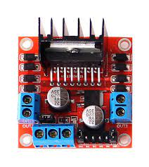

nRf24L01 Modules : <https://amzn.to/3uEF0ly>

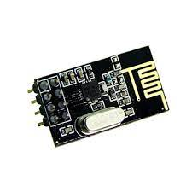

Joystick : <https://amzn.to/3hggzXM>

18650 Li-ion battery : <https://amzn.to/3twwcN5>



(If possible buy this from local shop)

Ultrasonic Sensor

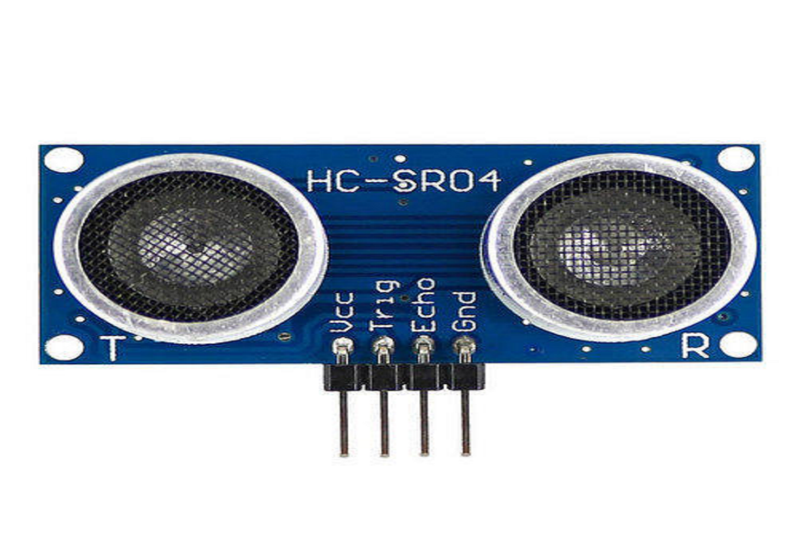

Male and female Jumper wire

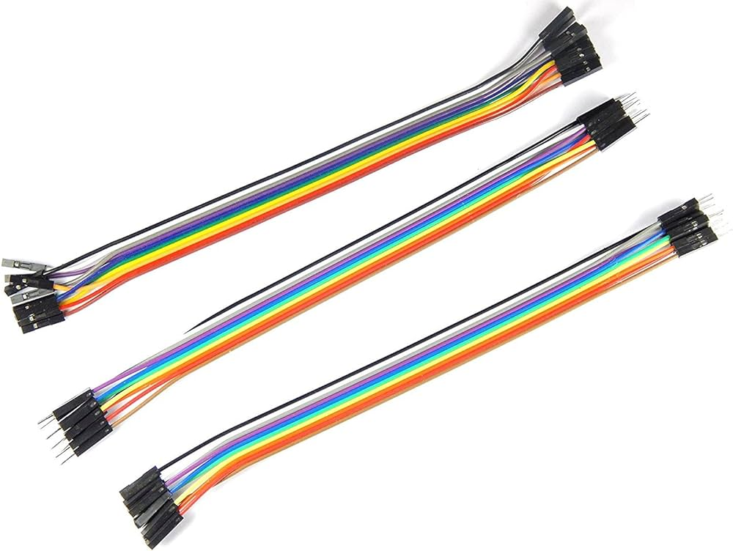

18650 Li-ion battery charger : <https://amzn.to/3uB7OLB>

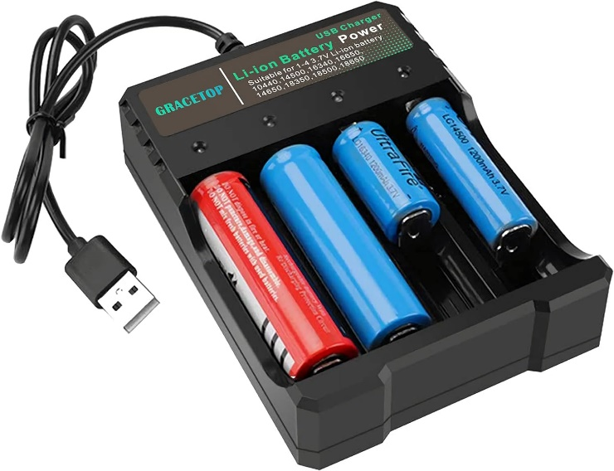

Battery Holders : <https://amzn.to/3vTmcz5>

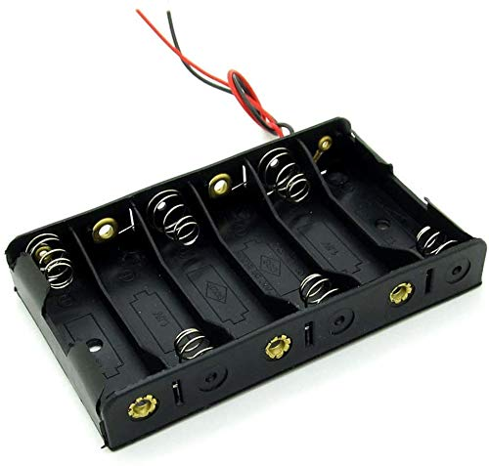

Wires : <https://amzn.to/2SFehY3>



General purpose PCB : <https://amzn.to/3vXr0Dx>​

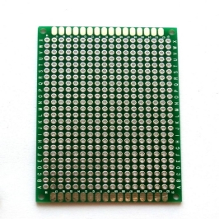

20 mm berg strips : I bought this from local electronics shop



TT Gear Motor

Wheels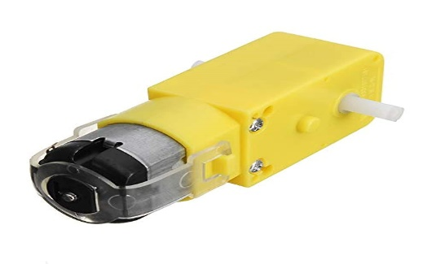

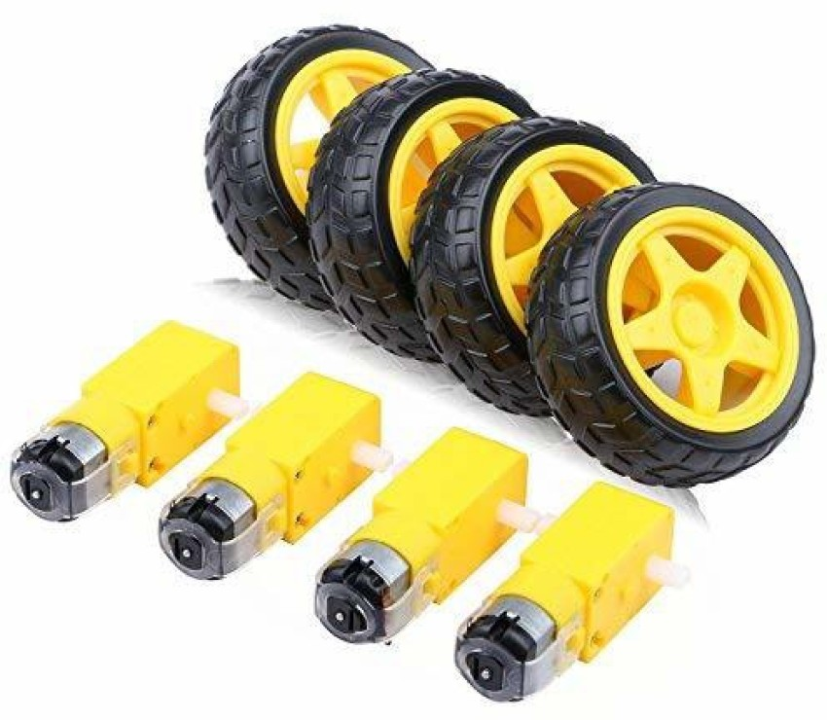

Arduino UNO :

The Arduino UNO is a popular microcontroller board renowned for its simplicity and versatility in prototyping electronics projects. Equipped with an ATmega328P microcontroller, it offers a wide range of digital and analog input/output pins, making it suitable for beginners and advanced users alike. With a user-friendly interface and an extensive community support network, the Arduino UNO enables enthusiasts to create interactive projects, from basic LED blinkers to complex robotics and IoT applications. Its compatibility with various sensors, actuators, and shields further expands its capabilities, making it a go-to choice for tinkering, learning, and innovation in the world of electronics and programming.

Arduino Nano:

The Arduino Nano is a compact and versatile microcontroller board, ideal for projects with space constraints or those requiring a smaller form factor. Based on the ATmega328P microcontroller, it offers similar functionalities to the Arduino UNO in a smaller package. Despite its size, the Nano retains a wide range of digital and analog input/output pins, enabling a diverse array of projects. Its USB connectivity allows for easy programming and power supply, making it accessible to beginners and advanced users alike. With its popularity among hobbyists, educators, and professionals, the Arduino Nano continues to be a go-to choice for prototyping, experimentation, and innovation in electronics and embedded systems.

L298 Motor Driver:

The L298 Motor Driver is a highly versatile integrated circuit (IC) designed for driving and controlling DC motors or stepper motors. It offers bidirectional control of two motors simultaneously, making it ideal for robotics, automation, and motor control projects. The L298 incorporates dual H-bridge circuits, allowing it to control the direction and speed of each motor independently.

nRF24L01:

The nRF24L01 is a popular wireless communication module known for its low power consumption and efficient data transmission capabilities. Operating in the 2.4 GHz ISM (Industrial, Scientific, and Medical) band, it enables reliable and robust communication over short to medium distances.

Joystick:  
A joystick is a manual input device commonly used in electronic systems, especially in gaming consoles, remote-controlled vehicles, and industrial control systems. It typically consists of a stick or lever that can be moved in multiple directions, along with one or more buttons for additional input

lithium-ion battery :

The 18650 lithium-ion battery is a rechargeable cylindrical cell widely used in various electronic devices, ranging from laptops and power tools to electric vehicles and portable electronics. Named after its dimensions (18mm in diameter and 65mm in length), the 18650 battery offers a high energy density and long cycle life, making it a popular choice for applications requiring reliable and high-capacity power sources.

Ultrasonic sensor:

The ultrasonic sensor is a device that uses sound waves at frequencies higher than the human ear can detect to measure distances and detect objects. It consists of a transmitter and a receiver that work together to send and receive ultrasonic pulses

Printed circuit board (PCB)

A general-purpose printed circuit board (PCB) is a board designed for use in a wide range of electronic applications. These boards typically have a standardized layout and configuration, allowing users to easily mount and connect various electronic components such as resistors, capacitors, integrated circuits, and connectors

Berg strips

Berg strips which are connectors used in electronics, particularly for connecting components on PCBs. These are often used for interfacing with various electronic modules, sensors, or other components in projects.

LilyPad

The LilyPad Light Sensor is a component designed for use in e-textiles and wearable electronics projects. Developed by SparkFun Electronics as part of their LilyPad series, it allows you to incorporate light-sensing capabilities into your wearable technology creation

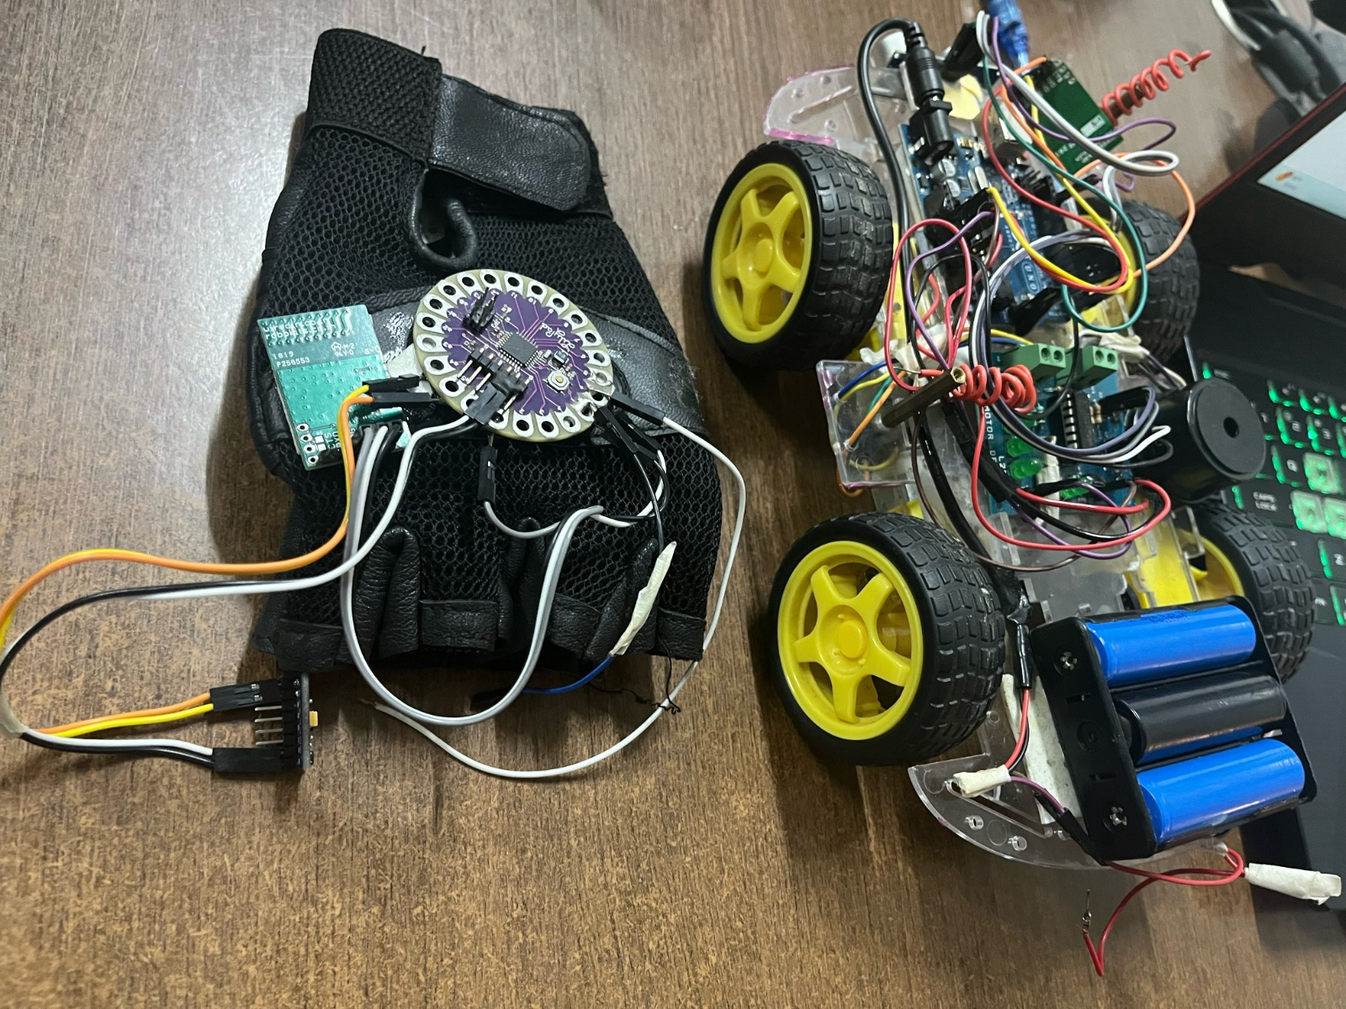

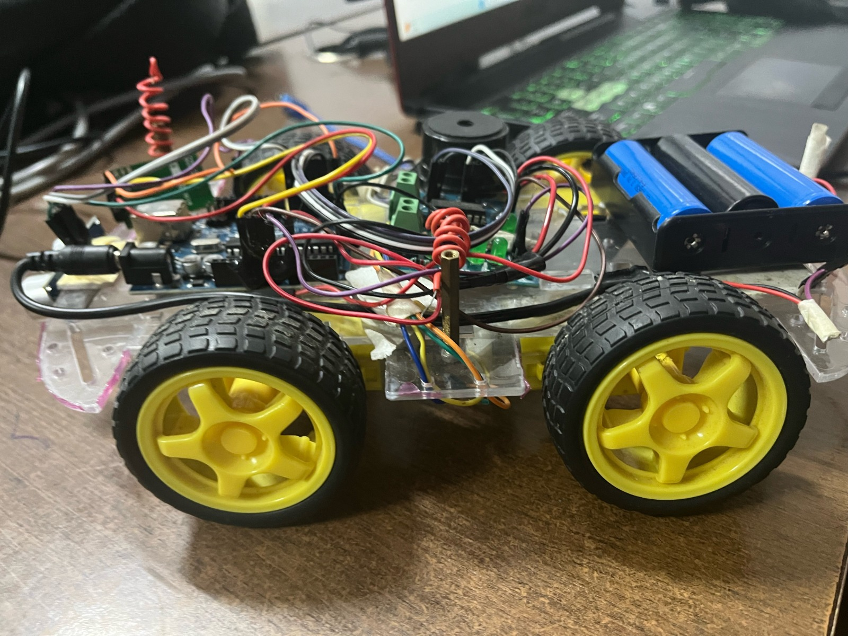

**Conclusion**

In summary, gesture-controlled technology is shaping the future of how we interact with cars. It offers a host of benefits, like making driving safer and more convenient while also opening up driving to a wider range of people. Although there are still some challenges to tackle, researchers are working hard to improve the technology.

Looking ahead, the possibilities are endless. Imagine a world where you can control your car with simple hand movements, keeping your focus on the road and making driving more enjoyable for everyone. With continued advancements, gesture-controlled cars have the potential to revolutionize the way we drive, creating a safer and more inclusive driving experience for all.

**References**

1. Academic Journals.

2. Conference Proceedings.

3. Textbooks on automotive technology and human-computer.

4. Industry Reports: Reports from market research firms or industry publications may offer insights into current trends and developments in gesture-controlled automobile technology.

5. Websites and Online Resources: Websites of automotive manufacturers, technology companies, and research institutions may publish white papers, case studies, or technical reports on gesture-controlled technology.